EXPERIMENT 5
- CREATE TABLE CUSTOMER(
CustomerID INT PRIMARY KEY,
CustomerName VARCHAR(30),
ContactNo VARCHAR(20),
Address VARCHAR(30),
City VARCHAR(30),
PostalCode VARCHAR(30),
Country VARCHAR(30)
);
DESC CUSTOMER;
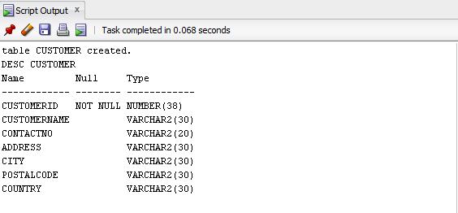
- CREATE TABLE Employees(
EmployeeID INT PRIMARY KEY,
LastName VARCHAR(30),
FirstName VARCHAR(20),
BirthDate DATE,
Photo VARCHAR(30)
);
DESC Employees;
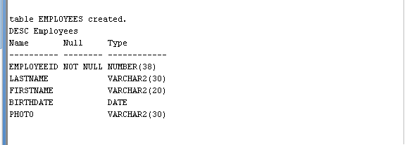
- CREATE TABLE Orders(
OrderID INT PRIMARY KEY,
CustomerID INT,
FOREIGN KEY (CustomerID)
REFERENCES CUSTOMER(CustomerID)
ON DELETE CASCADE,
EmployeeID INT,
FOREIGN KEY (EmployeeID)
REFERENCES Employees(EmployeeID)
ON DELETE CASCADE,
OrderDate DATE,
ShipperID VARCHAR(30)
);
DESC Orders;
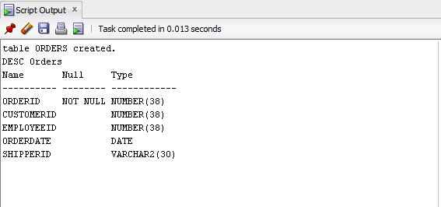
- INSERT INTO CUSTOMER VALUES(1, 'FEBHA', '987654321', 'MANGAF', 'KUWAIT', '103981', 'KUWAIT');
INSERT INTO CUSTOMER VALUES(2, 'SANJU', '876549322', 'FAHAHEEL', 'EGYPT', '90801', 'EGYPT');
INSERT INTO CUSTOMER VALUES(3, 'GEOPHY', '321654987', 'ABUHALIFA', 'IRELAND', 'LQASTA', 'UK');
INSERT INTO CUSTOMER VALUES(4, 'SHARON', '4567891233', 'FARWAHNIYA', 'DUBAI', '28001', 'UAE');
INSERT INTO CUSTOMER VALUES(5, 'INIYA', '963258741', 'AHMADI', 'KUWAIT', '98540', 'KUWAIT');
SELECT * FROM CUSTOMER;
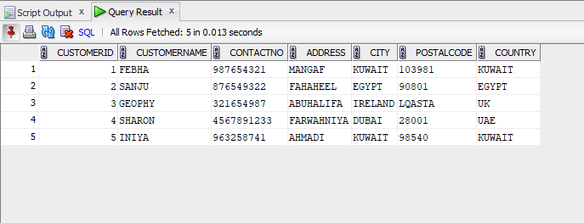
INSERT INTO Employees VALUES(1, 'S', 'ADITHYA', TO_DATE('1979-09-10','YYYY-MM-DD'), 'photo1.jpg');
INSERT INTO Employees VALUES(2, 'NP', 'ADITHYAN',TO_DATE('1981-06-15','YYYY-MM-DD'), 'photo2.jpg');
INSERT INTO Employees VALUES(3, 'S', 'AFFAN',TO_DATE('1998-01-25','YYYY-MM-DD'), 'photo3.jpg');
INSERT INTO Employees VALUES(4, 'V', 'ADARSH', TO_DATE('1999-10-23','YYYY-MM-DD'), 'photo4.jpg');
INSERT INTO Employees VALUES(5, 'BIJU', 'ABISHA', TO_DATE('1975-05-31','YYYY-MM-DD'), 'photo5.jpg');
SELECT * FROM Employees;
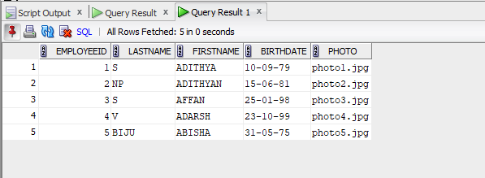
INSERT INTO Orders VALUES (1008, 1, 1, TO_DATE('2023-01-10','YYYY-MM-DD'), 1);
INSERT INTO Orders VALUES(1009, 2, 3, TO_DATE('2023-02-15','YYYY-MM-DD'), 2);
INSERT INTO Orders VALUES(1010, 1, 2, TO_DATE('2023-03-20','YYYY-MM-DD'), 1);
INSERT INTO Orders VALUES(1011, 3, 4, TO_DATE('2023-01-05','YYYY-MM-DD'), 3);
INSERT INTO Orders VALUES(1012, 1, 5,TO_DATE('2023-04-01','YYYY-MM-DD'), 2);
SELECT * FROM Orders;
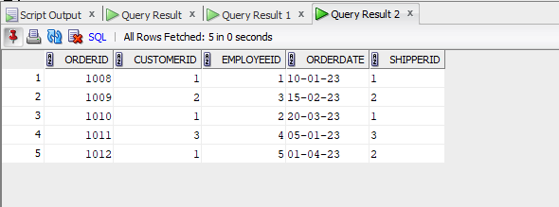

- SELECT * FROM Customer ORDER BY CustomerName ASC;
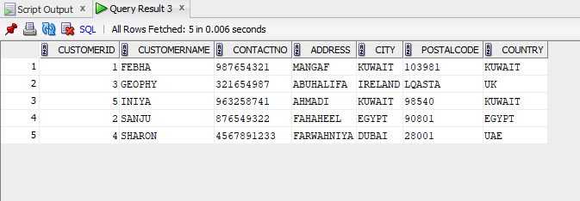

- SELECT * FROM Orders ORDER BY OrderDate ASC;

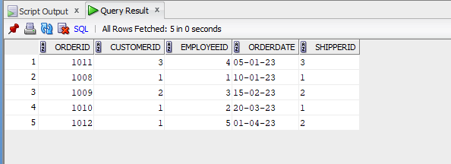

- SELECT * FROM Employees WHERE BirthDate > TO_DATE('1980-01-01','YYYY-MM-DD')ORDER BY BirthDate DESC;

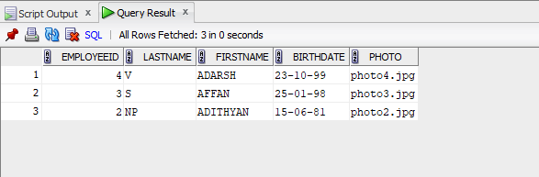

- INSERT INTO CUSTOMER VALUES(6, 'ROSE', '741852963', '1542 HARBOUR STREET', 'LA', '98540', 'USA');
INSERT INTO CUSTOMER VALUES(7, 'ALDA', '852147963', 'AVENUESTREET', 'NEW YORK', '521460', 'USA');
INSERT INTO Orders VALUES (1013, 6, 1, TO_DATE('2024-01-10','YYYY-MM-DD'), 1);
INSERT INTO Orders VALUES (1014, 7, 2, TO_DATE('2024-02-15','YYYY-MM-DD'), 2);
SELECT * FROM Orders WHERE CustomerID IN (
SELECT CustomerID
FROM Customer
WHERE Country = 'USA'
)
ORDER BY OrderDate DESC;

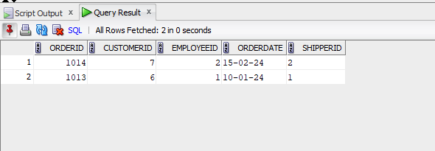
- SELECT C.CustomerName, COUNT(O.OrderID) AS TotalOrders FROM Customer C LEFT JOIN Orders O ON C.CustomerID = O.CustomerID GROUP BY C.CustomerName;
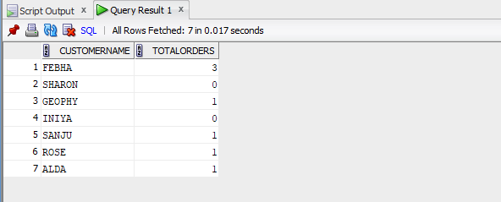
- SELECT City, COUNT(CustomerID) AS TotalCustomers FROM Customer GROUP BY City;
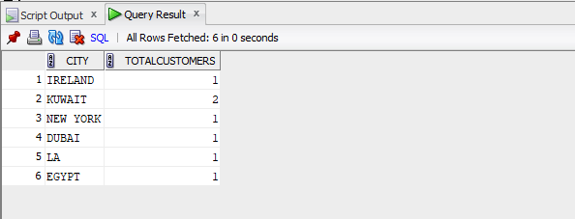

- SELECT C.CustomerName, COUNT(ORD.OrderID) AS TotalOrders FROM Customer C JOIN Orders ORD ON C.CustomerID = ORD.CustomerID GROUP BY C.CustomerName HAVING COUNT(ORD.OrderID) > 2;
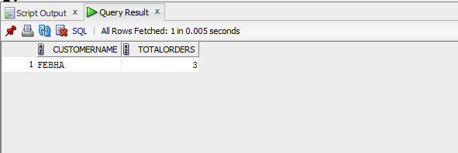

- SELECT City, COUNT(CustomerID) AS TotalCustomers FROM Customer GROUP BY City HAVING COUNT(CustomerID) > 3;
